Susquehanna Workforce Network (SWN)
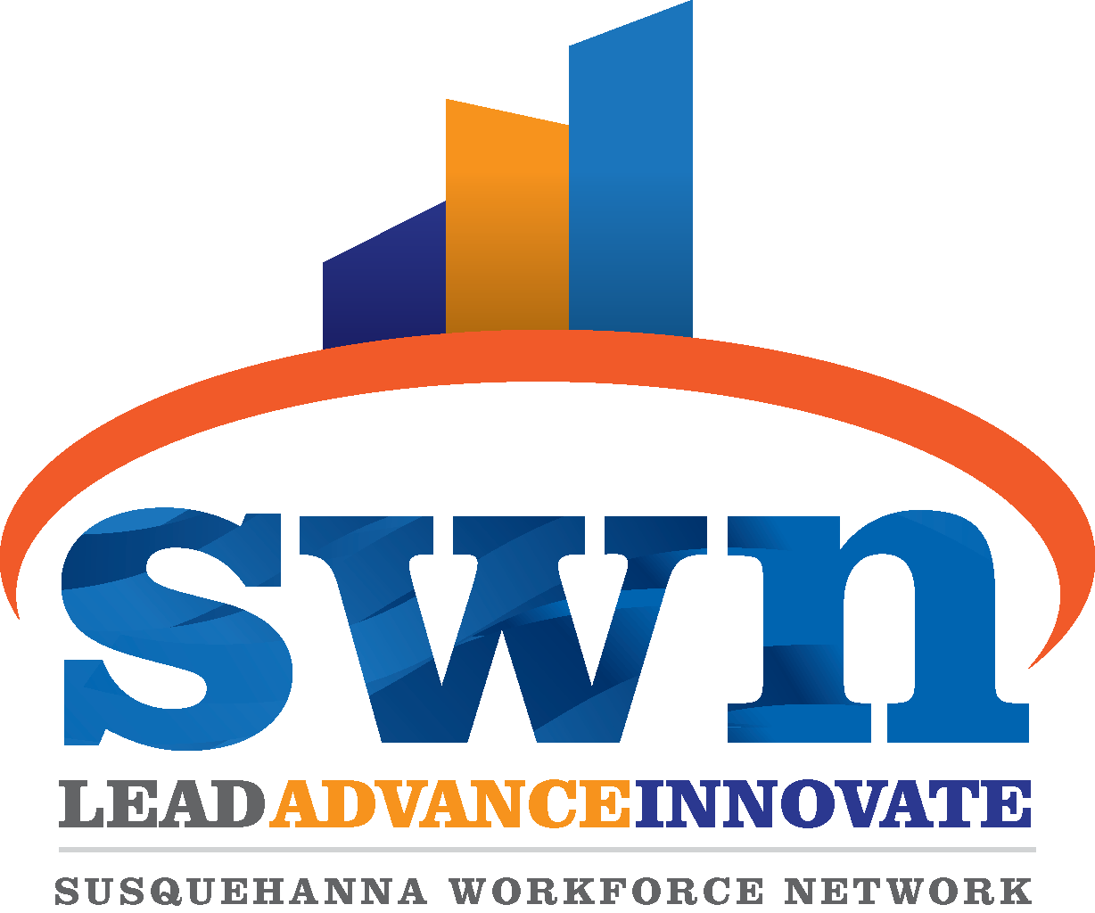
Steve Groft
Communications and Operations Specialist, SWN
410-996-0550
sgroft@swnetwork.org

FOR IMMEDIATE RELEASE
July 1, 2021

Susquehanna Workforce Network Hosts First In-Person Job Fair of 2021

Havre de Grace, MD — Now that Maryland has lifted all COVID-19 emergency mandates and restrictions, life in Cecil and Harford Counties is returning to normal. Jobseekers will notice the change later this month when the Susquehanna Workforce Network hosts its first in-person job fair since late 2019. It takes place Thursday, July 15, from noon to 4 p.m., at Minker Banquet Hall, 920 Principio Furnace Rd., Perryville, MD 21903.

Several Cecil and Harford County employers have signed up to participate in the first in-person job fair of 2021. As of today, participating employers include Allan Myers, APGFCU, Areas, Beacon Staffing Alternatives, Cecil County Government, Eastern Atlantic States Regional Council of Carpenters, Exact Staff, Herr's, Kiddie Academy, MacGregor's Restaurant, Medifast, Micropore, Inc., Pepsi, Recovery Centers of America, Upper Bay Counseling and Support Services, Upper Chesapeake Health, Waffle House, and Wicho and Sons LLC. More employers are being added daily and the participating employers are subject to change. Businesses that are interested in participating can register by calling Terri Kearney at 410-939-4240 (for Harford County businesses) or Alan Sexton at 410-996-0550 (for Cecil County businesses). The job fair is free for job seekers and no pre-registration is required. Job seekers are encouraged to dress professionally and to bring copies of their resumes.

“We are pleased and excited to host our first in-person job fair of 2021 and the first since late 2019,” said Bruce England, Executive Director of the Susquehanna Workforce Network. “Employers in Cecil and Harford Counties are ready to hire and residents here are ready to return to work. Being able to host an in-person job fair underscores how far we have come in the past few months.”

More information is available by calling 410-272-5400 or 410-996-0550.

The Susquehanna Workforce Network, Inc. (SWN) is a private, nonprofit 501(c)(3) corporation that oversees, coordinates and plans workforce development programs and services for businesses and residents in Cecil and Harford Counties in Maryland. SWN is headquartered in Havre de Grace and has Workforce Centers in Elkton and Havre de Grace, and a work-based training program office in Havre de Grace.

######

